RAFT Leadership Call September 2024 – Urgency Culture

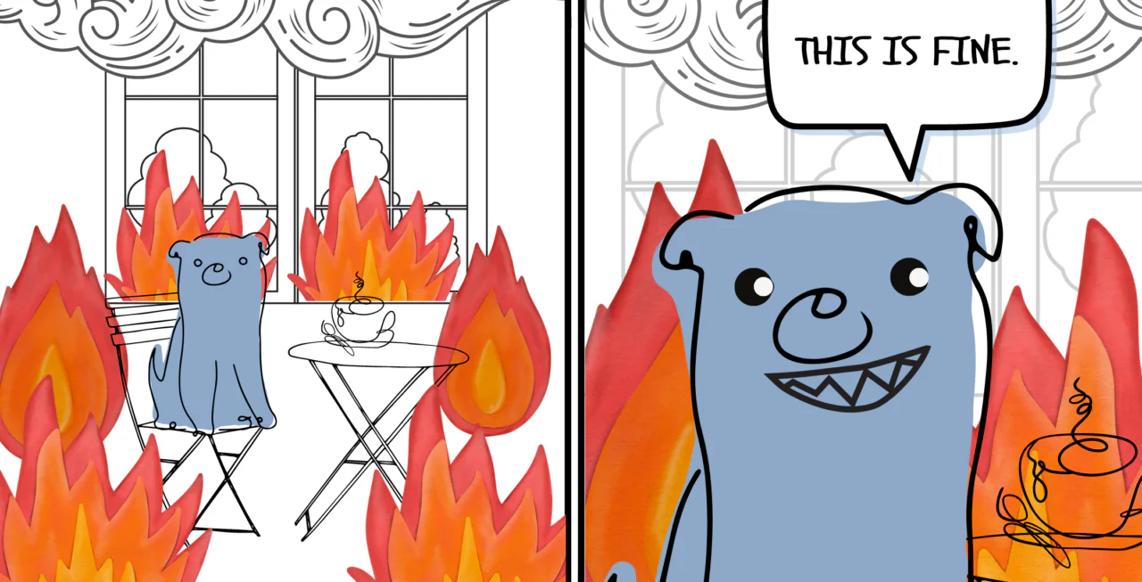

<https://ions.ca/resisting-a-rest-how-urgency-culture-polices-our-work/>

**Real urgency versus false urgency versus accepted urgency**

**Real urgency:** truly time sensitive and critical tasks that require immediate attention. In GBV these tasks will often be associated with a risk of harm (physical, mental, system) if not completed quickly. Examples: active abuse situation at the shelter, team experiences trauma that needs to be addressed, last minute court case change that requires paperwork or attendance.

**False urgency**: arises due to incorrect priorities, unrealistic timelines, high workloads, understaffing, broken systems, missing policies, lack of debriefs and change. Examples: paper work due in a few weeks being completed instead of prepping for a court appointment, leaving grant paperwork too late, working in shelter while answering crisis calls, short staffed shift but expect same work to be done, a system not taking into account the time for outside partners to respond.

**Accepted urgency** – events or tasks that are not truly urgent, and everyone knows this, but, over time the culture of an organization has accepted that these tasks will always be urgent and changes cannot be made. False urgency that is not identified and changed will become a culturally accepted urgency. Examples: grant reports will always be last minute or late, shelter intake must be done as fast as possible, 50% staffing must serve 100% of client load.

Examples of Sense of Urgency

* Frequently results in sacrificing potential allies for quick and highly visible results. For example, sacrificing the interests of BIPOC people and communities in order to win victories for white people (seen as default or norm community)
* Reinforced by funding proposals that promise too much work for too little money and by funders who expect too much for too little.
* Involves unrealistic expectations about how much can get done in any period of time.

Ways to disrupt sense of urgency:

* Realistic work plans based on the lived experience of the people and organization involved.
* A commitment to learn from past experiences how long things take.
* Leadership that understands that things take longer than anyone expects
* Clarity ahead of time about how you will make good decisions in an atmosphere of urgency (including clarity about what constitutes a “good” decision)
* An understanding that rushing decisions takes more time in the long run. People left out of decisions due to urgency will resent or undermine decisions when they are not heard.

Questions to ask about urgency culture in your organization:

* How does a sense of urgency show up in my work?
* How have I seen a sense of urgency show up in my organization?
* What is one way I can disrupt a sense of urgency in my personal life? My work life? My team? My organization?
* How is one department in my organization causing urgency for a different department? (cross-department conversations)

**Activity**

1. What criteria would you use to identify real urgency, versus false urgency, versus accepted urgency?
2. What events/tasks in your organization can you list in each of these categories?
3. For each event/task listed, what is the source of the urgency. Try to be as specific as possible? Examples: active danger, leadership decisions, other departments, court system, communication errors, etc.
4. For each source list one positive change you could make to start changing the sense of urgency with this event/task. For real urgency tasks list a positive change you could make that would better prepare your team, reduce the level of urgency, shorten the length of urgency, or reduce stress over the urgent event/task.

|  |  |  |  |  |  |
| --- | --- | --- | --- | --- | --- |
| Real Urgency Event/Tasks | Source | False Urgency Tasks | Source | Accepted Urgency Tasks | Source |
| Real Urgency Events/Tasks | | Source | | Positive change | |
|  | |  | |  | |
| False Urgency Events/Tasks | | Source | | Positive Change | |
|  | |  | |  | |
| Accepted Urgency Events/Tasks | |  | |  | |
|  | |  | |  | |

**Four Delegation Categories**

**“Do it, and don’t tell me.”** – tasks that people on your team are doing, or can do that you don’t need to know about. These are often the recurring tasks that happen day to day that your team knows how to do and the results of those tasks aren’t something you need to know. Many leaders struggle with their time because they are hearing to much about tasks that fall into this category. By making it clear to your team members which tasks fall in this category, you can save lots of time. Micromanaging leaders are usually too involved in these types of tasks.

**“Do it, and tell me.”** – tasks that your team is doing, that you don’t need to be involved in, but you need to know the results. When your team knows they can carry out the task without having to give you step-by-step updates, and only share the results, you can save a huge amount of time. This can save even more time if you can “batch” the communication of the results into specific times when you can hear multiple results at once, instead of one result at a time.

**“Don’t do it until you tell me.”** – these are most likely new tasks or projects that people want to do, or changes people want to make that you need to have input on, or ongoing input on. Your goal with these tasks (when it is possible) is to move them into one of the two previous categories and operationalize those tasks so you don’t have to deal with them.

**“Don’t do it, I have to do it.”** – these are the tasks you need to be involved in and continue doing, or be a part of doing. These are the tasks you can’t delegate.

**Letting Go of Projects** – check the leadership resource page to download this document.

**Make SMART requests when asking for help**

How to ask for help workshop recording and workbook - <https://www.raftcares.org/HTAFH/>

**S- Be Specific**

Assess the situation you need help with and break it down into specific requests.  
 Example: Vague request – Can you help me in the shelter today?  
 Specific request – Can you help me organize the supply room today?

**M – Make it measurable**

How does your supporter know they’ve helped enough? Be clear on what their help looks like when complete.

Example: Once we have all the new food off the floor and on the shelves, we will be

done.

**A – Must be achievable**

Ask someone with the knowledge, skills and resources needed to successfully accomplish your request.

Example: Ask someone on your team with a strength in organizing. Make sure the

person you ask is physically able to help with putting food on shelves.

**R – Be realistic/reasonable**

Your request should be respectful of individual capacity.

Example: You may actually need help with the whole supply room, but making a

smaller ask for just help with the food may be more reasonable.

**T – Set a timeline**

Your request should be timebound so set a due date and/or checkin date to ensure follow through.

Example: We have more groceries coming in tomorrow, so if we need to be finished

by end of day today.

**Reporting and Debriefing false/accepted Urgency**

Create a system for people to identify an event/task in the organization that is urgent but doesn’t

* Green light, yellow light, red light
* Stoplight/Spotlight
* Anonymous reporting

Potential Debriefing process/questions

* Provide a summary of what happened/is happening with as much detail as possible. Give an opportunity for more than one person to add to the summary so that all information is available.
* Apply your criteria for an urgent task that your team has created – Does the event/task meet the criteria for real urgency?
* What worked? Why?
* What didn’t work? Why?
* In an ideal situation how would the organization respond to this event/task?
* What could we do differently next time to achieve ideal results in this situation?
* What organizational strengths could help achieve this ideal situation?
* How would everyone act/do to achieve this ideal situation?
* What systems need to be added/changed to achieve this ideal situation?
* What policies need to be added/changed to achieve this ideal situation?
* What resources are needed to achieve this ideal situation?
* What communication changes are needed to achieve this ideal situation?
* What does the timeline look like to achieve this ideal situation?
* What else needs to happen to achieve the ideal results in this situation?

**General ideas/notes for removing urgency**

* When you add something to someone’s list/take something off their list. Don’t make people so busy regular tasks become urgent.
* Work with your team to clearly prioritize tasks and timelines to reduce false or accepted urgency
* Ask questions/make requests and give time for people to think before having to give a response.
* Communication plan for urgency versus non-urgent channels. Use the urgent channels only for urgent matters – RAFT communications SOP
* Make sure to build a non-urgent culture for everyone. Leadership can tend to put urgency onto those they lead.
* Having a clear mission, vision, and strategic plan for your organization and using these as a filter for decision-making can help you identify what is truly urgent.
* RAFT Blog: Urgency Culture: Understanding its Impact on Decision-Making & Performance: [The Impact of Urgency Culture on Decision Making & Performance – Raft Cares](https://www.raftcares.org/resources/community-blog/urgency-culture/)
* 5 Tactics to Combat a Culture of False Urgency at Work: [5 Tactics to Combat a Culture of False Urgency at Work (hbr.org)](https://hbr.org/2023/10/5-tactics-to-combat-a-culture-of-false-urgency-at-work)