**RAFT Leadership Call April 2024 Imposter Syndrome**

**Imposter Syndrome:**

* a persistent internalized fear of being exposed as a fraud as you doubt your skills, talents, and accomplishments. Even when you are successful these doubts persist. (Wikipedia)
* Feeling anxious and not experiencing internal success despite being high-performing in external ways. (BetterUp)
* People who struggle with imposter syndrome believe they are undeserving of their achievements. They feel they aren’t as competent or intelligent as others might think, and that soon people will discover the truth. Often linked to perfectionism. (Psychology Today)
* The stories we tell ourselves about not being enough

**Causes of Imposter Syndrome**

* Struggle with feeling effective
* Perfectionism
* age
* Anxiety, emotional instability, self-doubt, depression
* Culture and environment
* Family dynamics
* Past experiences/trauma
* Interpersonal trauma involving a lack of safety or support in past relationships (ACE)
* ADHD

Imposter syndrome is more prevalent in women, and specifically women of color.

**Books:**

Song of Significance – Seth Godin

Meditations – Marcus Aurelius

The Creative Habit: Learn it and use it for life – Twyla Tharp

**Displacement**

You only have a set amount of time each day to get everything done, with your work, and in your life. This means that every time you add something to your day/week/month/year, something else is getting pushed back, or knocked completely off your list. This is “displacement” the idea that when you add something, something else gets pushed off your list until later, or completely disappears (until much later when it often pops up as a now urgent task).

Start tracking your displacements each day, which will help you compare what you think you did each day, versus what you actually did that day. This can be extremely helpful in fighting the “voices of doubt” that whisper that you are a bad leader, don’t get anything done during the day, are lazy, should be fired, etc.

**Tracking displacement.**

If you already have a task list, add a second column. In this second column write out each task you carried out that day that wasn’t on your original schedule or task list. At the end of the day (or a time period of your choice) circle items on your task list that didn’t get done, and count the number of displacements in column number two. Realize you had a busy day, got lots done, it just wasn’t the work you had planned on doing.

Bonus: make a third column and track the amount of time spent on each task and each displacement to get a better idea of how much time you are putting towards displacements.

**85% Capacity is the goal**

If you are scheduling 100% of your time (or your team’s time) then you can be more susceptible to imposter syndrome. Scheduling 100% of your time leaves no room for emergent displacements: tasks, meetings, emergencies, etc that will take up your time.

Aim to schedule 85% of your time and leave 15% of your time for these emergent displacements. As you track your time and displacements you may realize that your position requires you to leave even more time for displacements.

**Jeremie’s Daily Check in/Checkout Journal Questions**

**Top 5 Tasks**  
1.

2.

3.

4.

5.

**Gratitudes:**

1.

2.

3.

**Mood:**

**Displacements:**

**Checkout:**

**Priority task(s) for tomorrow:**

**Critical Awareness**

Defined as knowing why something exists, how it works, how our society is impacted by it, and who benefits from it. Critical awareness increases our personal power in three ways by giving you the ability to:

1. **Contextualize** – see the big picture. Look at all of the good you have done, everything you have accomplished, the people you have supported. Looking at the big picture helps you shift away from focusing on only what has gone wrong, or isn’t working.
2. **Normalize** – realize you are not alone or the only one. Talk with someone, or check the internet, or think of past experiences to connect with the fact that other people have experienced what you have experienced and you are not alone.
3. **Demystify** – understand the source and share with others. Look at organizational, cultural, societal and other sources that may be causing you to feel this way. Then find someone in your success pack to talk with and shine a light on what is happening. This will help you see your successes and accomplishments and not focus on the negatives.

**Problem to Opportunity Exercise – Reframng Conversations**

[**https://youtu.be/k_4eN5L49gc?si=9qs4gRfky7FqBBDX**](https://youtu.be/k_4eN5L49gc?si=9qs4gRfky7FqBBDX)

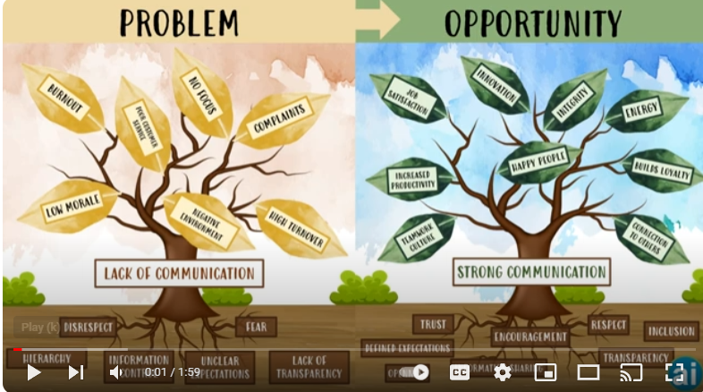

1. Determine the problem (the trunk of your tree) and write it down.
2. Write all the factors contributing to the problem. These are the roots of your tree.
3. Write all of the outcomes that are occuring because of the problem. These are the leaves of your tree.
4. Write the positive opposite of your problem as the trunk of a new tree.
5. Write all factors contributing to this positive opposite. These are the roots of the new tree.
6. Write out all outcomes that occur because of the tree's positive trunk. These are the leaves of the new tree.

**Imposter Syndrome and Adverse Childhood Experiences – Psychology Today**

[**https://www.psychologytoday.com/ca/blog/hidden-wounds/202401/the-imposter-syndrome-and-adverse-childhood-experiences**](https://www.psychologytoday.com/ca/blog/hidden-wounds/202401/the-imposter-syndrome-and-adverse-childhood-experiences)

* List of characteristics – how many do you have?
* List of solutions