**Types of Leadership Transparency**

Transparency with:

|  |  |  |  |
| --- | --- | --- | --- |
| Yourself  Trusted Network  Mastermind groups  Leadership team  Whole organization | Less Risky  More risky | Less Impact  Impact | More lonely  Less lonely |

**Questions to ask yourself or your team**

What is on your mind?

What is the real challenge here for you?

What do you want?

If you're saying yes to this, what are you saying no to?

How can I help?

What is most useful or valuable here for you?

**To go deeper follow up any of these questions with:** And what else?

It’s not about the nail: <https://youtu.be/-4EDhdAHrOg?feature=shared>

[](https://youtu.be/-4EDhdAHrOg?feature=shared)

**Ideas on what to share when being transparent**

- project/program updates - share even if there has been no change

- what is working in the organization, and you would like to see more of

- what is not working in the organization and ideas to make changes (or ask for ideas)

- reasons for big decisions you have made (bonus: start including more people in some of those decisions)

- updates, information, and decisions around grants and other funding

- reasons for specific policies

- reasons for changes made in the organization

- mistakes you have made

- more information about you (as much as you are comfortable sharing)

- more explanations and examples of your job and what you do (I can almost guarantee they are wondering)

**Appreciative Inquiry Coaching Questions**

1. What’s going on for you since the last time we talked?
2. What possibility/project/task would you like to focus on this week/month/quarter (whichever timeline you are using).
3. Tell me about this possibility/project/task?
4. What are your strengths as they relate to this possibility?
5. What opportunities do you see in this situation?
6. What do you most aspire to achieve with this possibility/project/task?What is your vision?
7. What action/goal are you willing to commit to?
8. What results will indicate your progress?
9. When you complete this possibility/project/task what becomes possible?
10. What action will you commit to for this week/month/quarter (whichever timeline you are using).
11. What resources do you need?
12. Who could you connect with to further this effort?

**Psychological Safety (**[**https://blog.talkspirit.com/en/psychological-safety-at-work-why-important-how-to-promote-it/**](https://blog.talkspirit.com/en/psychological-safety-at-work-why-important-how-to-promote-it/)**) (**[**https://www.leaderfactor.com/learn/culture-of-psychological-safety**](https://www.leaderfactor.com/learn/culture-of-psychological-safety)**)**

Psychological safety is an employee’s ability to take risks, share ideas, and challenge the status quo without fear of negative consequences. Psychological safety destigmatizes failure and grants the right to make mistakes.

Psychological safety creates an environment where people can be their authentic selves, take risks, and contribute to the organization’s success. It allows for more collaboration, innovation, and better performance. Team members trust each other, feel accepted for who they are, and believe their contributions are valued.

Psychological safety:

* Creates more engagement
* Reduces turnover
* Improves performance
* Improves wellbeing and mental health

Transparency looks like clarifying:

* Roles, responsibilities, and accountabilities
* Policies and work processes
* Tools used and how to use them

**Building psychological safety**

Leadership: model vulnerability, embrace diverse perspectives, encourage open dialogue.

Effective communication: build open and transparent communication channels. Promote active listening and constructive feedback. Encourage people to express themselves.

Feedback and recognition

Trust building activities

Psychological safety training

Psychological Safety and Transparent Communication at Work: <https://mediaspace.msu.edu/media/Psychological+Safety+and+Transparent+Communication+at+WorkA+Strengthening+Collaboration+and+Innovation/1_fqkk7m2f>

**Transparency and trauma informed practices**

Substance Abuse and Mental Health Services Administration lists “trustworthiness and transparency” as one of their principles of trauma informed care. They define this as:  
  
organizational operations and decisions are conducted with transparency, with the goal of building and maintaining trust among staff, clients, and others in the organization. Trustworthiness and transparency aren’t always easy – they require honesty, lots of time devoted to communication, and acknowledgement of accountability by families and providers alike.

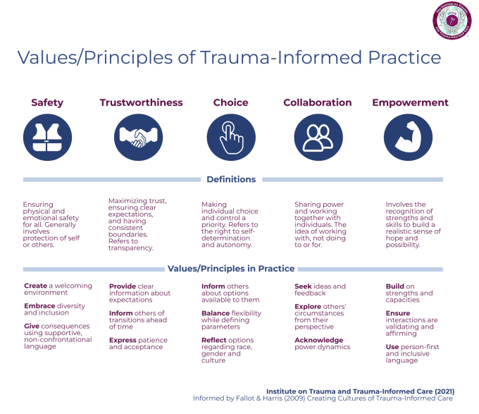

**RAFT Examples of Transparency**

**Kick off meeting** – RAFT has started working in 2-week increments. At the start of the 2 weeks each team member shares what they are working on and ask for the support they need. Other team members accept these requests for help, or adjust the request to fit their work schedule. At the end of each 2 weeks the team does a debrief (we are still working on the format for these)

**Gratitudes** – at the start of every RAFT team meeting each team member shares something they are grateful for. This is one of the simplest methods of transparency as you are sharing something positive and doesn’t have to be work related.

**SOAR Strategic Planning** – in the fourth quarter of every year the entire RAFT team works together on the strategic plan for the following year (and a rough plan for the next three years).

**New Ideas and Program updates** – Jeremie provides the team with updates on new ideas or programs at team meetings and on our Slack channel. These updates are sometimes “there is no update” but it lets the team know these ideas and programs are still being considered and worked on.

**Well-being –** the RAFT team shares well-being updates in our Slack channel letting the team know when they aren’t feeling well (mentally and physically) and won’t be able to attend a meeting, or need coverage.

**Diversity, Equity, Inclusion, and Belonging** – RAFT has initiated a DEIB review process where twice a year the team fills out the RAFT DEIB survey. The results will then be sent to an outside person to process and anonymize to ensure safety for each team member in sharing their experiences. These answers will then be used to create a discussion guide that the team will use to explore the results of the survey using appreciative inquiry.

**Transparency in Job Postings**

* Include pay/salary range