**Management and Leadership: Differences and Commonalities**

Leadership vs management: <https://www.youtube.com/watch?v=-wTbUr3BmJg>

* There is overlap and some significant differences.
* Simply: Manage projects, lead people.
* Management = what, leadership = how

**Glossary of Terms**

* **Leadership:** the action of leading a group of people or an organization; the state or position of being a leader.
* **Leadership skills:** Leadership skills are the abilities, qualities, knowledge, and behaviors that enable a person to effectively guide, coach, inspire, and influence others to complete the activities needed to achieve a common objective. These skills are comprised of interpersonal, communication, and organizational knowledge and abilities essential for leaders to motivate their teams, make sound decisions, and navigate complexities and challenges. s:
* **Management:** the process of dealing with or controlling things or people.
* **Management Skills:** the abilities and traits that people in managerial positions need to perform specific tasks and activities. These skills can include technical, human relations, and conceptual skills, and can be learned through experience, courses, or on the job.
* **Project Manager (management)**: A project manager is a professional who organizes, plans, and executes projects while working within restraints like budgets and schedules. Project managers lead entire teams, define project goals, communicate with stakeholders, and see a project through to its closure. Whether running a marketing campaign, constructing a building, developing a computer system, or launching a new product, the project manager is responsible for the success or failure of the project.
* **Program Manager (management)**: Program management is the process of coordinating, monitoring, and controlling an aligned group of projects. As a program manager, you'll manage a portfolio of related projects that impact the same parts of the organization or rely on each other to be delivered successfully. Program managers must coordinate multiple projects to avoid redundancy, track progress, and meet schedules.
* <https://www.coursera.org/articles/program-manager-vs-project-manager>

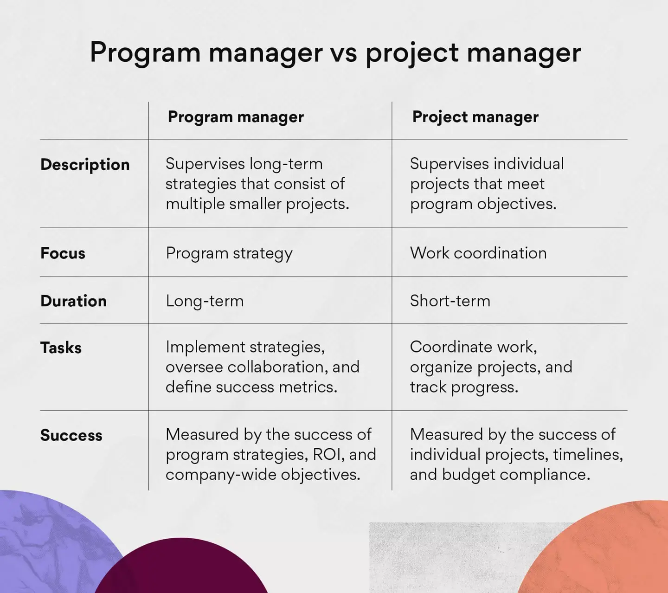

<https://asana.com/resources/program-manager-vs-project-manager>

**Effective Leadership Qualities**

1. **Effective Communication** - Leaders must articulate their vision, provide guidance and listen actively to their team. Strong communication skills ensure that messages are understood, fostering collaboration and trust.
2. [**Agility and adaptability**](https://www.imd.org/blog/leadership/leadership-skills/#item2) - leaders must be able to adapt to both internal and external changes, even if that means working outside of your comfort zone. They must develop a lifelong learning mentality to ensure that they are not left behind by shifts in their industry.
3. **Creativity** – Think outside the box. Innovative. Creativity enables people to solve problems in new or innovative ways.
4. **Motivation** - Leaders need to inspire their workers to go the extra mile for their organizations; just paying a fair salary to employees is typically not enough.
5. [**Decision-making**](https://www.imd.org/blog/leadership/leadership-skills/#item5)- Effective leaders thoughtfully align each decision with their broader vision and goals. They seek diverse opinions, carefully weigh the pros and cons, and then choose a course of action with conviction. This drives their objectives forward and builds trust and respect among team members, reinforcing the leader’s role as a trusted guide.
6. [**Conflict management**](https://www.imd.org/blog/leadership/leadership-skills/#item6)- A great leader knows how to avoid conflicts in the workplace and can also resolve them in an efficient and timely manner. While resolving conflicts, the leader stays level-headed and decides analytically.
7. **Self-Awareness** - Self-aware leaders understand their strengths and weaknesses. This awareness enables them to make informed decisions, leverage their strengths and work on areas that need improvement. It also allows them to relate better to their team members.
8. **Vision** - provides direction and purpose for their team. It creates a shared goal that motivates and guides everyone toward a common objective.
9. **Confidence** - every leader should demonstrate confidence to instill motivation. Even when obstacles impact progress, you should strive to exhibit poise and conviction.
10. **Empathy** - Empathy is the ability to understand and connect with others emotionally. Good leaders use empathy to build rapport, resolve conflicts and create a supportive and inclusive work environment. It shows team members that their leader cares about their well-being.
11. **Strategic Thinking** - Leaders need strategic and critical thinking skills, as they are tasked with challenging decision-making. A strong leader makes well-researched and objectively scrutinized decisions that can lead an organization toward achieving its goals.
12. **Accountability** - Accountability means taking responsibility for one’s actions and decisions. When leaders hold themselves accountable, they set a standard of responsibility for their team, fostering a culture of ownership and reliability.
13. **Respect** - Respect for all team members, regardless of their role or background, is essential for creating a harmonious and inclusive workplace. Leaders who demonstrate respect foster a culture of collaboration and mutual support, enabling everyone to thrive.
14. **Passion** - Passion fuels dedication and perseverance. Good leaders are passionate about their work and vision, which motivates them and inspires others to give their best. This enthusiasm can drive a team to overcome obstacles and achieve greatness.
15. **Resilience** - the capacity to [withstand](https://www.google.com/search?sca_esv=765881fa522ab74c&rlz=1C1CHBD_enUS879US881&q=withstand&si=ACC90nxMSPeZfdJJjQgDsdZJuFuJ03TSPuzcMTHanexnpkrKY7u2HDVGdtP_5WE-TbM6OgthMCWvPLnHqfYc6trp1C6569cmFsRmYYJvaBuiYgiOfE61Sr0%3D&expnd=1&sa=X&sqi=2&ved=2ahUKEwjjm7DH8JiHAxU5rokEHeHzDSkQyecJegQIDxAO) or to recover quickly from difficulties; [toughness](https://www.google.com/search?sca_esv=765881fa522ab74c&rlz=1C1CHBD_enUS879US881&q=toughness&si=ACC90nxMSPeZfdJJjQgDsdZJuFuJjdgwQ9J-X8t6sP2vouBq8bskeoPFXXhPKM_kLzz6ldmyi6w4Yu-1BZqy832g2NWRwZRD5SW4jVe-vay7aKUOBiyuNzQ%3D&expnd=1&sa=X&sqi=2&ved=2ahUKEwjjm7DH8JiHAxU5rokEHeHzDSkQyecJegQIDxAP). Good leaders bounce forward and don’t give up easily.
16. **Gratitude** - expressing gratitude goes beyond simple courtesy; it serves as an acknowledgment of the hard work and contributions of team members. This practice boosts morale and strengthens interpersonal relationships and fosters a positive work environment. Such an atmosphere becomes a catalyst for motivation and productivity, reinforcing the leader’s role as an uplifting and empowering presence.

**Effective Management Qualities**

1. **Organization** - Organizational skills are your abilities to manage time effectively, prioritize tasks, set goals, and develop systems for achieving those goals. Employees with good organizational skills can juggle multiple responsibilities simultaneously, stay focused on deadlines, and handle complex projects efficiently.
2. **Time Management** - the coordination of tasks and activities to maximize the effectiveness of an individual's efforts. Essentially, the purpose of time management is to enable people to get more and better work done in less time.
3. **Teamwork -** a group's collaborative effort to achieve a common goal or complete a task effectively and efficiently.
4. **Delegation** - to assign a particular job, duty, right, etc. to someone. As a manager, you must delegate responsibilities to your staff.
5. **Leadership** - the action of leading a group of people or an organization; the state or position of being a leader.
6. **Research** – Look up information, study policies, procedures, and different subjects, find answers to questions.
7. **Project Management tools and software** -
   1. **Collaboration tools** like Google Sheets, Google Drive, and Dropbox
   2. **Work management tools** like Asana, Trello, Jira, and Smartsheet
   3. **Scheduling tools** like digital calendars and Gantt charts
   4. **Communication tools** like email, chat, and video conferencing software
8. **Team Management** - Evaluating performance effectively, delegating tasks responsibly, and handling conflicts
9. **Budgeting** – Keeping track of how much money you have and how much money you spend. Knowing where costs might pile up, and how to prioritize tasks and delegate resources.
10. **Planning** - **Planning** enables you to build the foundation on which the budget, timeline, and scope of the **project** will rest in perfect harmony.
11. **Scheduling** - management of staff schedules, activities, deliverables, and milestones within a project. A comprehensive project schedule must include start and completion dates, total duration, and resources associated with each milestone. Project scheduling is an essential step in the successful time management of a project.

* **Are you a project manager or a program manager? (You can be both.)**
* **Are you a leader, manager, both?**
* **What does that look like when you are exemplifying the best leadership and management traits? How is that reflected in your team’s performance and agency outcomes?**
* **Where/how do you use these skills in your leadership roles?**
* **What skills do we already have?**
* **How well are we using those skills?**
* **In what areas can we improve our skills?**
* **How do we improve the skills we have/gain new skills?**
  + Attend trainings (webinars, conferences, classes)
  + Read books
  + Listen to podcasts
  + Find a mentor
  + Ask for help