**RAFT Leadership Call March 2024 – Effective Communication**

**Creating clear tasks**

What needs to be done – who needs to do it – when it needs to be done – what completion looks like (make the obvious explicit).

Example: Suggestions on the new workshop document need to added by the workshop team by Friday March 15th. Completion looks like all your suggestions entered into the comments section of the word document.

**Team Communications SOP (see separate document for RAFT example)**

**External Communications:** list all channels/methods used for communicating with external partners/organizations.

**Internal Communications:** list all channels/methods used to communicate with your internal team.

**Communication Asks:** list specific requests for how the team communicates, how often the team communicates, how the team checks information messages, etc.

List each communication channel. Explain how the channel is used in general. List specifics for using that channel internally and externally. List what not to use that channel for.

List helpful information about the different channels you use, and separate SOPs for those channels if you have them.

**Progressive Stack**

**Definition:** The progressive stack is a technique used to give marginalized groups a greater chance to speak. This works by allowing people to speak on the basis of race, sex, and other group membership, with preference given to members of groups that are considered most marginalized.

As a leader the progressive stack, for me (Jeremie), means that the person with the most power in the room speaks last, and the people with the least power in the room speak first. As a leader you are most often than not going to be the one with the most power in the room, which means you need to spend time listening and then, when everyone has had a chance to speak, it’s your turn to talk.

You need to be truly listening and be open to considering other ideas, and not listening and calculating what your response is going to be, or judging what the other person is saying.

“**We have two ears and one mouth, so that we can listen twice as much as we speak.**” - Epictetus, Greek Philospher.

**“Listen to understand, not to respond.” - unknown**

**Johari Window**

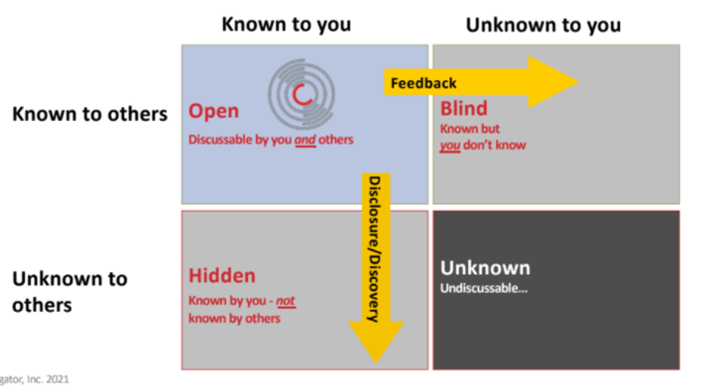

The more information we have in the top left pane, the larger that window grows (moving the mullions) and the healthier a relationship will be.

Feedback expands the window by others sharing information with you.

Disclosure/discovery expands the window as you share information with others.

It is difficult to have a clear perspective in a conflict if there is information that is unknown to you, and unknown to others.

Many conflicts arise or escalate due to unknown information.

**Possible Questions to use with JoHari window**

What information can we both get clear on and agree with?

Do I have information I need to share with this person?

Do you have any information I need to know?

Can you share any feedback you have about me that would help this discussion?

Is there any truly unknown information contributing to this conversation?

**HALT**

Before you meet with anyone to discuss something check on:

**H**ungry - (crucial physiological need – air, food, water, warmth, safety)

**A**ngry/Anxious

**L**onely

**T**ired

**RIVERS** (six underpinning causes of conflict)

Reality (facts/experience/data)

Interests (concerns, hopes, expectations, aspirations, priorities, beliefs, loves, desires)

Values

Emotions

Relationships (with others and yourself)

Systems, structures, state of mind

**RAFT Team Meeting Template**

At the start of the meeting, or before the meeting is scheduled, ask if anyone else on your team would like to lead the meeting so you are not leading every meeting in your organization. This shares power and gives other people in your organization a low-risk way to be a leader.

|  |  |  |  |  |  |  |
| --- | --- | --- | --- | --- | --- | --- |
| **Item** | **Notes/Documents** | **Person** | **Status** | **Priority** | **Est. Agenda Time** | **Link** |
| **Notes** |  |  |  |  |  |  |
| **Gratitudes** |  |  |  |  |  |  |
| **Spotlight/Stoplight** |  |  |  |  |  |  |
| **Team Show and tell** |  |  |  |  |  |  |
| **New Agenda Item #1** |  |  |  |  |  |  |
| **New Agenda Item #2** |  |  |  |  |  |  |
| **Recurring Agenda Item #1** |  |  |  |  |  |  |
| **Recurring Agenda Item #2** |  |  |  |  |  |  |
| **Appreciations** |  |  |  |  |  |  |

**Notes/Documents:** Information that is needed to discuss whatever item in the list.

**Person:** This is the person or persons that “own” the item on the agenda and are bringing it to the team meeting.

**Status:** RAFT uses “working on it” “stuck” and “Done” for this column. “Working on it” means we have not covered the agenda item. “Done” let’s us have the satisfaction of checking the item off the agenda. “Stuck” means that, even once the item has been discussed at the meeting, we are still stuck on moving forward.

**Priority:** RAFT uses “Today”, “By next meeting,” or “whenever” to signify when this item needs to be dealt with. This allows us to put items on the agenda that may not be covered in that meeting, but we won’t forget them later. It also helps us to organize the items on the agenda, so we get to “today” items first.

**Estimated Agenda Time:** list how long the person in charge of the item thinks it will take to discuss so you can try and organize items to fit in the time you have available for the meeting.

**Link:** links to online resources that may be needed for the item.

**Notes:** a reminder to make sure someone on the team is taking notes for the meeting.

**Gratitudes:** start each meeting sharing gratitudes. First person shares a gratitude, then picks the next person to share a gratitude, that person shares a gratitude, picks the next person, etc. If your organization is too big to share gratitudes as a whole group, you can split into smaller groups and have people share gratitudes.

**Spotlight/Stoplight:** team members can choose to share a stoplight (something happening that is affecting them or something they are working on) or a spotlight (something exciting that is happening).

**Team Show and Tell:** a team member can share a process or system, so others know how to do it, something they created something that happened to them while working, etc. RAFT mostly uses this to teach the team new systems or software.

**New Agenda Item:** Insert as many new items as possible that need to be discussed during the meeting.

**Recurring Agenda Item:** List items that you cover or may cover every team meeting. Sometimes the person in charge of these items may say there is nothing to discuss, but these items hold space on the agenda, so they are not forgotten. Some items RAFT has as recurring agenda items: calendar review, workshop updates, content updates, outreach updates, software updates.

**Appreciations:** people who wish to share appreciations about the organization, people in the organization, clients, etc. share their appreciation to close the meeting. Not everyone has to share an appreciation.